RADIAN GENERATION

Customer Portal Customer Walkthrough &
Quick-Start Guide
A step-by-step guide to finding support, submitting requests, tracking tickets, and using the MSS Support knowledge base.
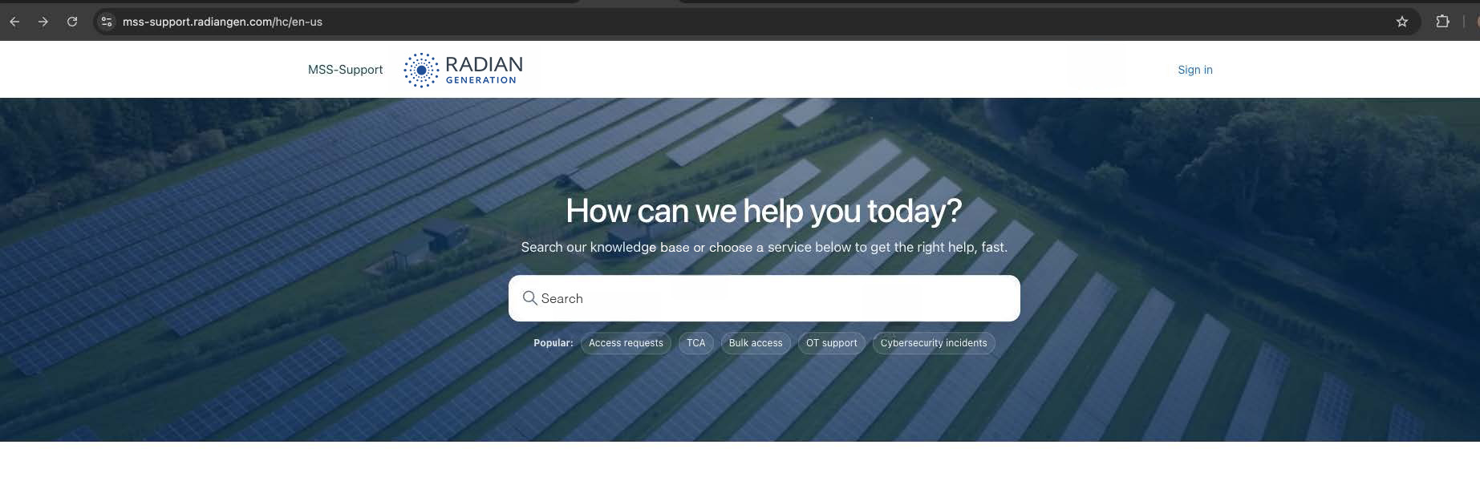
1. Welcome to the New Radian Customer Portal 2
- What you can do 2
- Quick navigation 2
2. Start at the Portal Home Page 3
3. Sign In and Access Your Tickets 3
- New users: email verification 4
4. Choose the Support Service 4
5. Start a Support Request 5
6. Review Suggested Articles Before Submitting 6
7. Complete Request Details 6
8. Select the Request Category 7
9. Select the Subcategory 7
10. Use the Help Items Shown With Your Request 8
11. Complete Request Submission 9
- Verify Email 9
- Customer Submission Checklist 9
Need help right away? 9

Welcome to the New Radian Customer Portal
The new portal provides a single place to search support information, submit service requests, report cybersecurity incidents, request access, and track your tickets.

What you can do
- Search the knowledge base before opening a ticket.
- Choose the right support service so your request is routed appropriately.
- Submit detailed requests with site, system, impact, timing, and other relevant information.
- Use suggested articles to quickly find troubleshooting guidance while completing a request.
- Track your requests through the My Tickets area after signing in.

Quick navigation
Portal Area | Use it for
Search | Find help articles and troubleshooting guidance
Access Request | Request access to systems, tools, or data
TCA | Request temporary or contractor access
OT Support | Report SCADA, network, or operational technology issues
Cybersecurity Incidents | Report suspected cybersecurity, phishing, or physical security incidents
Request for Information | Request reports, access lists, or site information
My Tickets | Sign in and track the status of submitted requests

Start at the Portal Home Page
Open the customer portal in your browser. The home page is designed to give you two fast paths: search for an answer, or choose the service that matches your need.
- Sign in — Use this when you need to access your account or track tickets.
- Search — Enter keywords describing your issue or question.
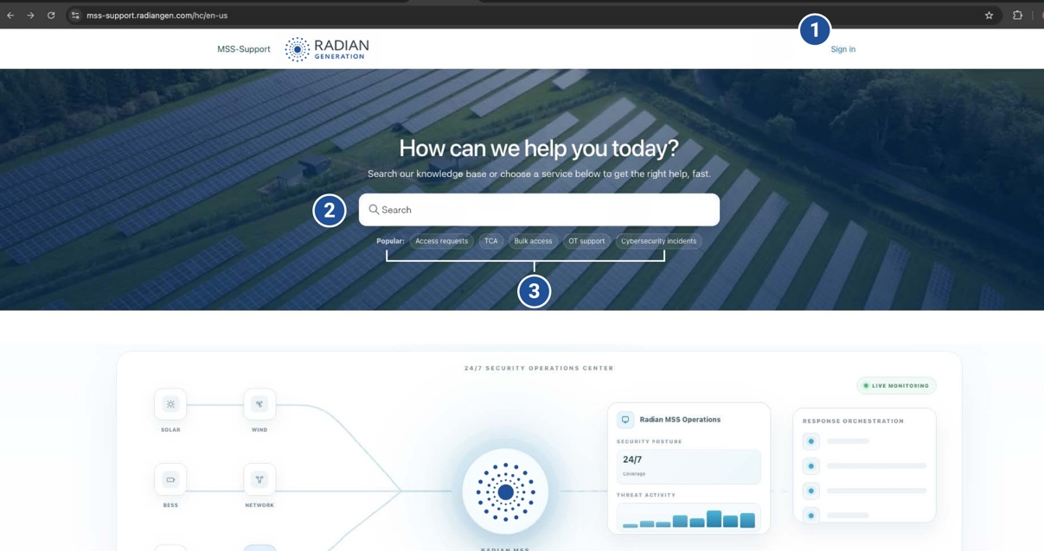
- Popular topics — Quick links to common request types.
Figure 1: Portal home page
Tip:
Start with a short description such as “telemetry loss,” “VPN access,” or “TCA request.” The portal may surface relevant help articles before you submit a request.

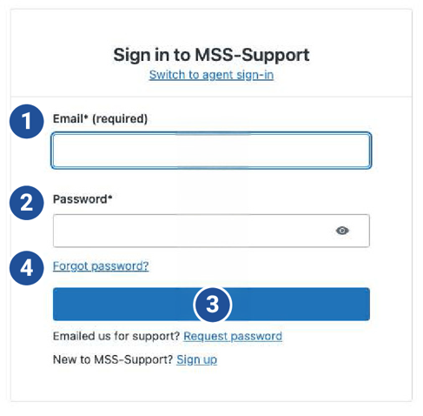
Sign In and Access Your Tickets
When you select Sign in or My Tickets, the portal opens the customer authentication page.
- Enter your email address associated with your portal account.
- Enter your password.
- Select Sign in.
- If you cannot access your account, use Forgot password? link or the account-support options shown on the page.
Figure 2: Sign in page

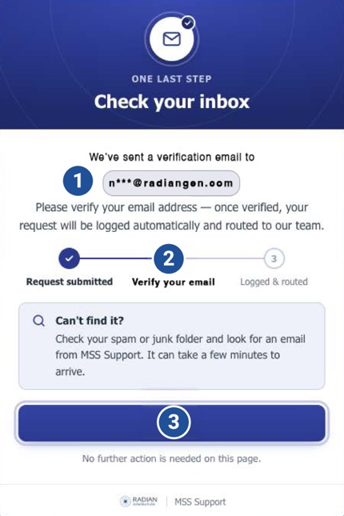
New users: email verification
If you are a new end user, the portal may ask you to verify your email address. The request is not fully routed until the email verification step is completed.
- Request submitted: The portal confirms the request was entered.
- Verify your email: Open the verification email sent to the address you provided.
- Logged & routed: After verification, the request can be logged and routed to the support team.

Choose the Support Service
Figure 3: New-user verification screen. Check your inbox and complete the verification link.
From the Support Services section, choose the option that best matches what you need. Selecting the closest service helps direct your request to the appropriate workflow.
- Access Request — Request access to systems, tools, or data.
- TCA — Request temporary or contractor access to sites, systems, or equipment.
- OT Support — Report SCADA, network, or operational technology issues.
- Cybersecurity Incidents — Report suspected cybersecurity, phishing, or physical security incidents.
- Request for Information — Request reports, end-user access lists, or general site information.
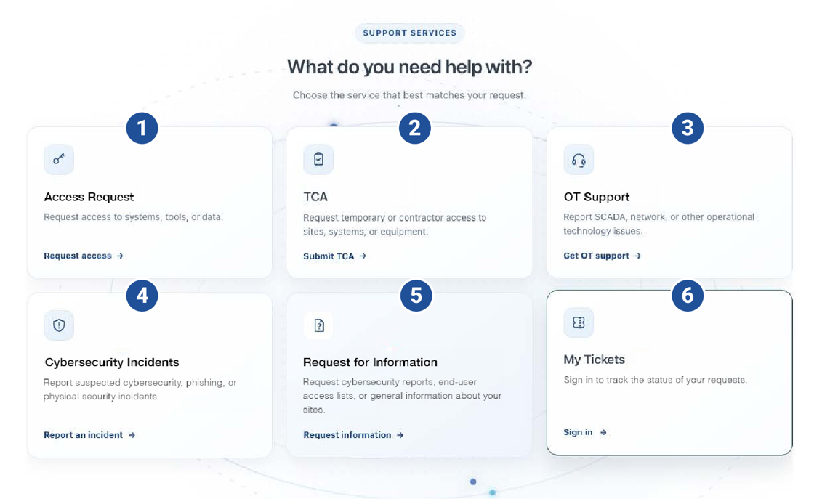
- My Tickets — Sign in to view and track your requests.
Figure 4: The six primary customer-facing service options.

Start a Support Request
Tip:
Provide clear details as part of your subject.
- Good example: “Sunset Peak – Telemetry loss from inverter group 3 since 09:19 ET”
- Less Useful: “Site issue”
Choose the appropriate service and select the option to submit a request. The request page guides you through the information needed by the support team.
- Confirm the email address that should receive updates.
- Enter a clear subject that summarizes the issue or request.
- Provide your first and last name.
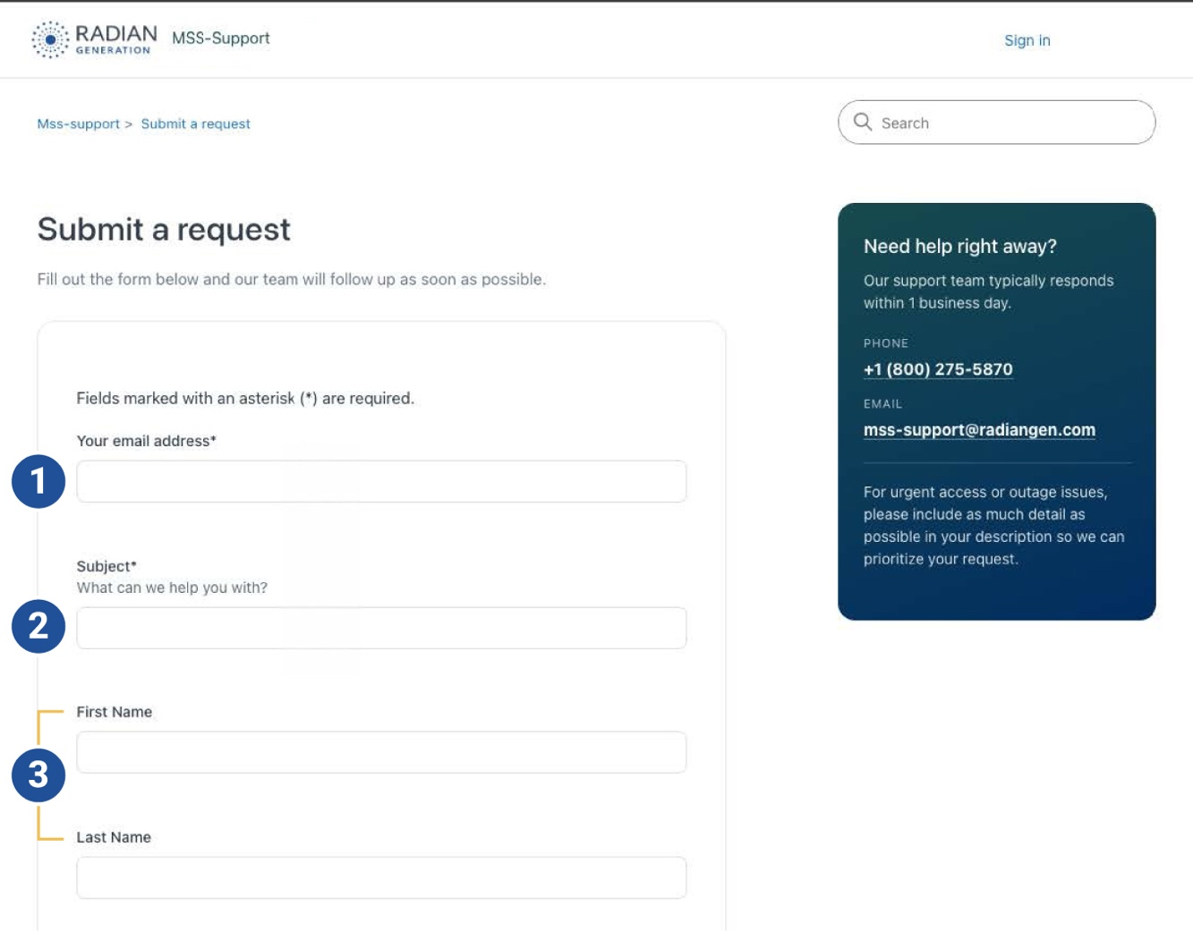
- Description: Explain what happened, when it started, what is affected, and any troubleshooting already performed. Provide enough detail for the team to understand the situation without needing to ask for basic information.
Figure 5: Beginning of the submit a request workflow

Review Suggested Articles Before Submitting
As you type in the subject and/or request details, the portal will display suggested knowledge base articles. These are intended to help you resolve common issues quickly and provide the information support needs for escalation.
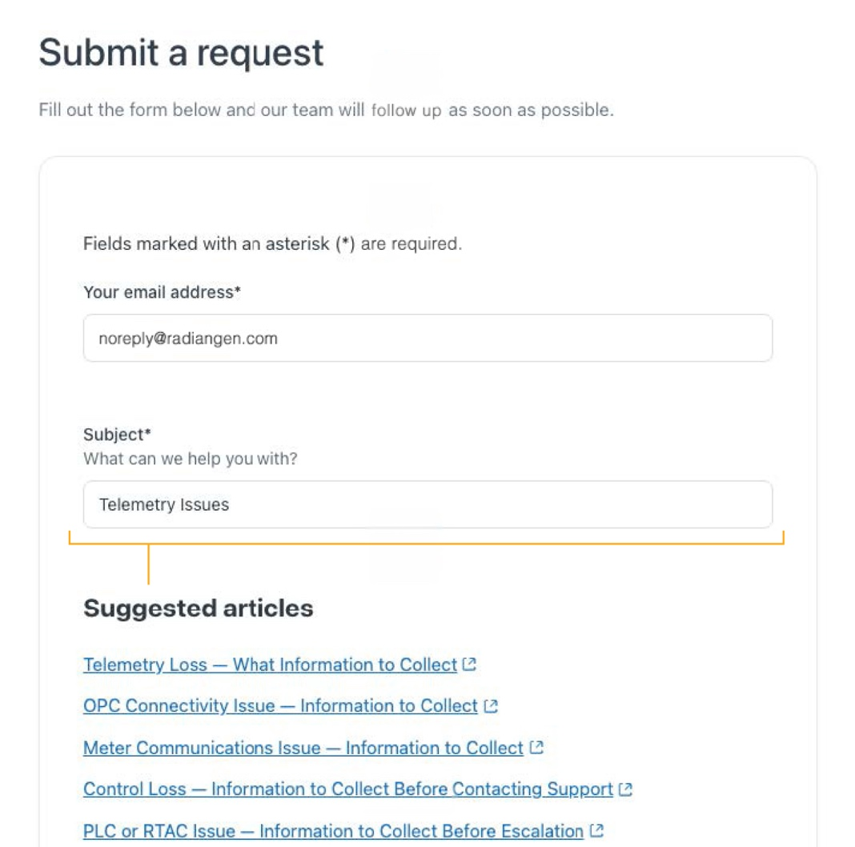
Figure 6: Suggested articles appear based on the information entered.
If an article answers your question, follow the guidance provided. If you still need assistance, continue completing the request form.

Complete Request Details
Where the suggested articles do not provide enough resolution, continue filling out the submission form. Complete information allows the support team to identify the site, affected system, timing, and operational impact.
Tip:
For operational issues include the site, affected equipment/system, approximate start time, whether the issue is site-wide or limited, exact alarms/messages, screenshots (when available), and any recent changes.

Select the Request Category
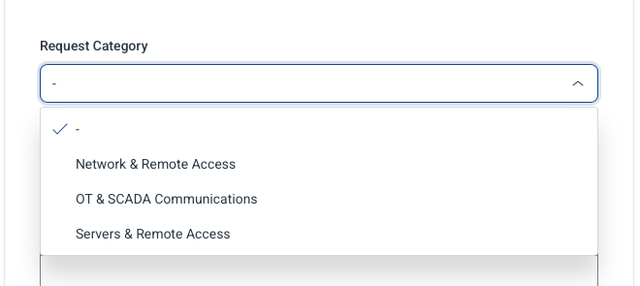
Use Request Category to identify the general technology or service area. The available choices shown in the portal include:
- Network & Remote Access
- OT & SCADA Communications
- Servers & Remote Access
Figure 7: Category selection

Select the Subcategory
After choosing a Request Category, select the most specific subcategory available. The choices may change based on the category selected.
For SCADA and OT communications, the portal currently shows several options including, but not limited to:
- Telemetry loss
- PLC/RTAC issue
- OPC connectivity
- Meter comms
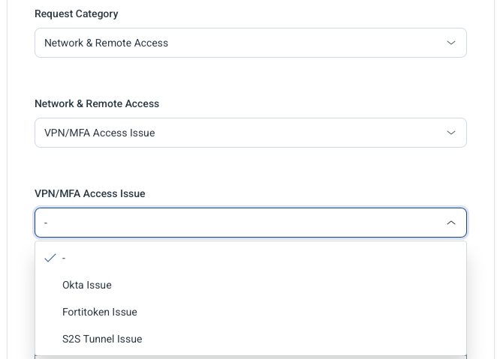
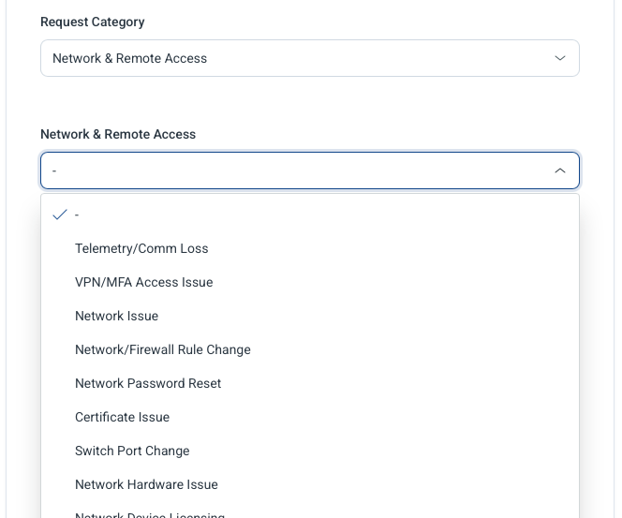
Selecting the most specific option helps the support team understand the request before opening the ticket. Additional secondary sub-categories may appear based on the subcategory chosen.
Figure 8: SCADA and OT Subcategory Selection
Figure 9: Additional subcategory options for VPN/MFA access

Use the Help Items Shown With Your Request
The portal may display contextual help alongside the request form. These cards can provide a short checklist of information to include before you submit.
For the telemetry example shown, the portal prompts the requester to include:
- Site name and affected system/device
- Approximate start time and whether the loss is partial or site-wide
- Exact alarm/message and a screenshot when available
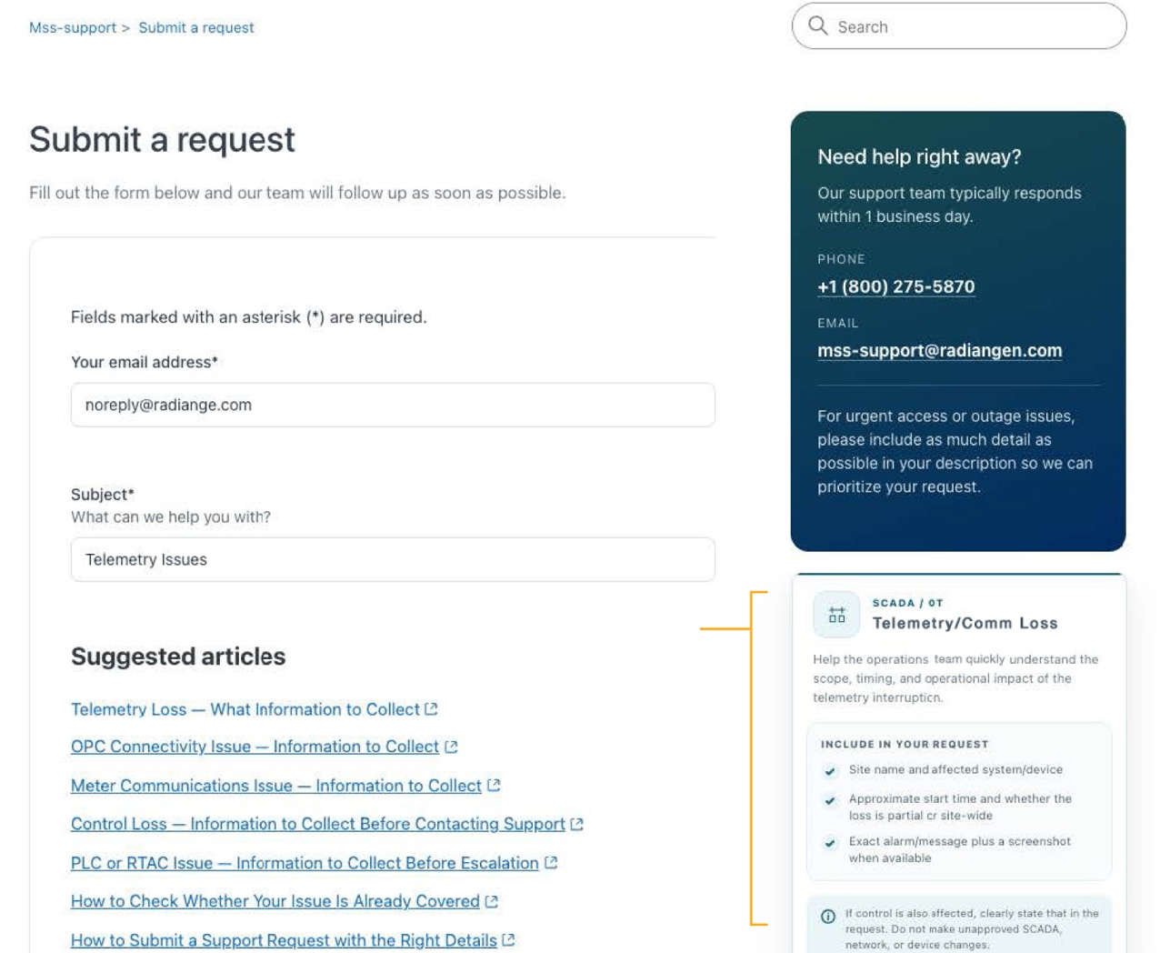
If control is also affected, clearly state that in the request. Do not make unapproved SCADA, network, or device changes as part of troubleshooting.
Figure 10: Suggested items for Telemetry request

Complete Request Submission

Verify Email
For new end users, the portal may display a verification screen after the request is submitted. Check the inbox for the verification email and complete the verification link. See page 3 for details.

Customer Submission Checklist
Before selecting Submit, use this quick checklist for operational and technical requests:
- Correct site name
- Affected system, device, or service
- Clear description of the issue/request
- Approximate start time and current status
- Degree of impact (partial or site-wide)
- Relevant alarms, error messages, or screenshots
- Any recent changes that may be related
- Correct Request Category and Subcategory
- Best contact information for follow-up

Need help right away?
The portal's support panel provides the current support contact information. For urgent access or outage issues, include as much detail as possible in the request so the team can prioritize and respond appropriately.
Portal | mss-support.radiangen.com/hc/en-us
Email | mss-support@radiangen.com
Phone | +1 (800) 275-5870

Thank you for using the Radian Generation MSS Support Customer Portal.

